AGENTIC AI

1. IT PERCIEVES REASONING ACTING LEARNING
2. Understands the goal, figures out the steps, uses the right tool, adapts as it goes
3. Agentic ai follows 4 step loops
- PERCEPTION - The agent gathers the data in the form of API's, Databases, user chats, sensors or web searches.
- REASONING - Breaks down the task, plans what to do and decides while tools or API’s to use. Sometimes it also taps in external knowledge using RAG (Retrieval Augmented Generation) Module to get real time data
- ACTION – It actually executes the steps such as making API Calls, Writes code, Sends E-mail, even runs shell commands and if something fails it self corrects it
- LEARNING – Based on how things go well agents store the experience. Over time it gets at handling situations better.
4. 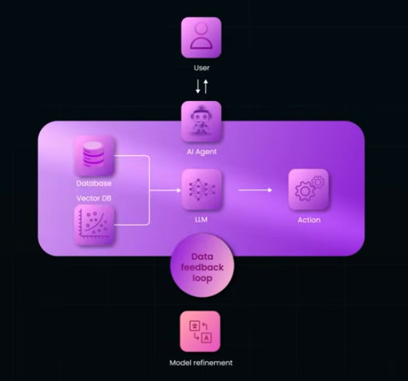
4. AI Agent – At the centre powered by an AI LLM, brain doing heavy reasoning.
5. Perception - It connects to Databases to gather the context
6. Action - Plans and takes action like calling APIs or executing the tasks.
7. DATA FEEDBACK LOOP – Every action and data gets stored which improves the agent over timeand that’s how it learns continuously refining itself. It uses Tools – System – Data
8. 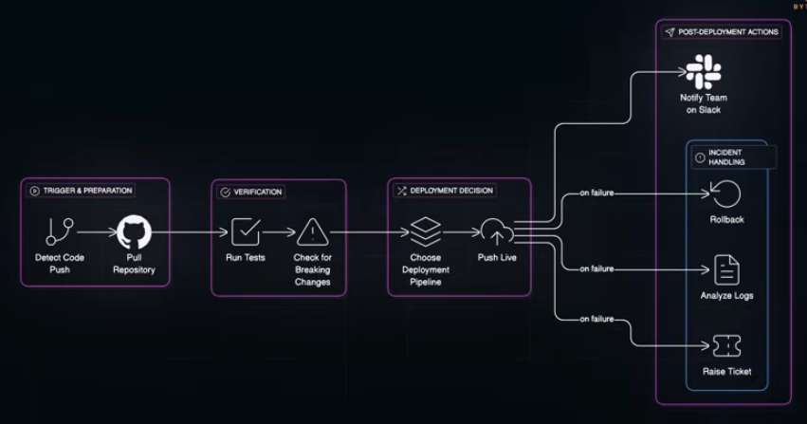
9. Traditional AI and Assistants are REACTIVE. They wait for you to to tell them what to do, one prompt at a time
10. Agentic AI is PROACTIVE. It takes the goal and runs with it. It doesn’t just assist, it acts, it adapts and learns.
11. How to build AI Agents?
- LLM – It is agent’s brain. It does all tasks reasoning, breaking down tasks, planning actions and figuring out what to do next. Ex: Claude, GPT 4
- Memory Layer – This helps them to stay on track, remember the past steps and learn from the outcomes,
    - Short Term Memory – conversation history
    - Long term memory with vector databases – Pinecone, Weaviate, FAISIS to recall previous results or decisions. f
- Tools or APIs – allows your agent to do stuff in the real world, Tools can be calc, db query, code executor or even a shell access Ex:
    - Run tests
    - Submit Pull Requests
    - Check CI/CD Pipelines
- Orchestration Framework – used to glue it all together. You give agent a goal like ship this feature and the framework breaks that into steps, manages the memory, routes decision and connects the LLM to tools. It basically defines the work flow. Popular choices
    - Langchain: Great for chaining the steps and building the modular Agents
    - Open Ais Agent SDK: Fast Moving and tightly integrated with Open AI tools.
    - Crew AI: create the teams of the agents with defined rules
    - Autogen by Microsoft: Helps collaborate work via a structured chat flows.
- 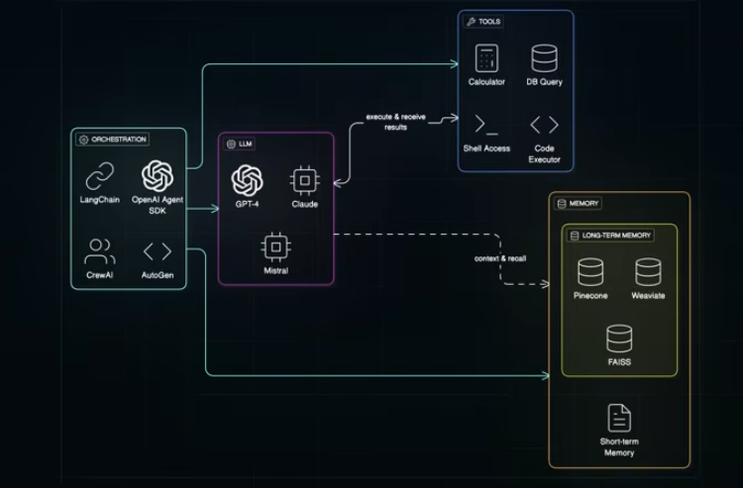

12. EXAMPLE: AI agent that can deploy the code safely
- Pick an LLM – GPT 4 To understand the instructions and plan deployment steps.
- Memory – Redis or pinecone – to Track which services were deployed past failures
- Tools – Github API to pull code or create PR’s, CI/CD APIs like circleCI, Github actions and shell commands
- Framework – Lang chain or Open Ais Agent SDK to orchestrate the workflow and handle the retries if something breaks
- Agent handles
- Pulling the repo
- Kicking off deployment
- Logging Results
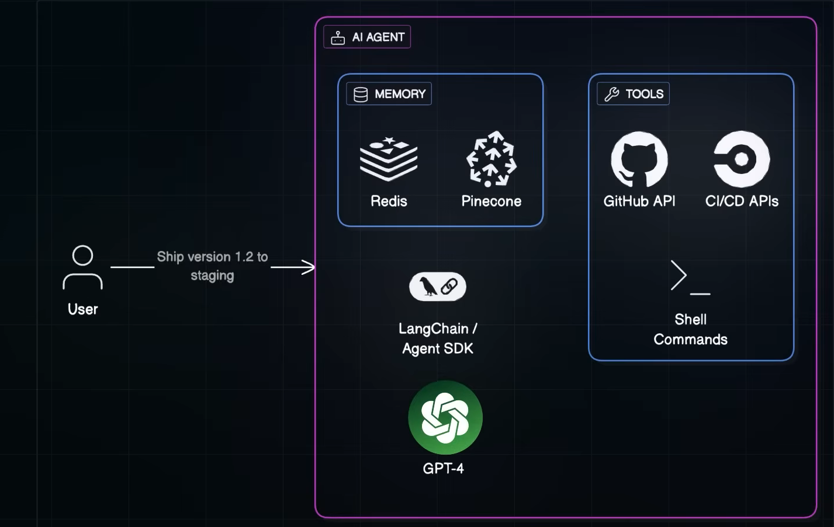

13. This needs some kind of structure so we use
- MCP – Model Context Protocol
- Defines the coordination of (multiple tools and APIs in Agentic AI.)
- Structures the conversation, tools calls, memory access
- Smart Middle Layer – amking sure each component in your system understands the full context of whats happening

